Project report
PROJECT NAME: Healthy Us

PREPARED BY: Pranay Sai Renduchintala - 300311943

Jacky Lam - 300307441

Vinay Kolli - 300316562

Sevilay Ardik – 300323961

COURSE: CSIS 3175-002

Project Manager

May 2012

Table of Contents
Introduction 3
Technical Requirements 3
App Activities/Classes and Screens 3
Project Team and Roles 5
Project Features and Functionality 6
Database 7
Summary 9
References 9

Introduction
The project aim is to develop an android application that keeps track of the calories consumed per day and provides the flexibility to connect to doctors in a locality. Users can also post complaints to their respective doctors. The patient can check the doctor’s availability or book an appointment using this application. The data entered at every point of the app are saved to the database tables. We have named our App as “Healthy Us” which reflects the goal of our Health Management Application.

Technical Requirements
The technical requirements for successful running of project are as follows:
- IDE: Android Studio
- Programming Language: Java
- Emulator: Pixel_3a_API_30_x86
- Database: SQLite

App Activities and Classes
Here are the list of classes and their activities used for the app
App Activities and Classes
Project Name: Healthy Us
No | Classes | Activity | Features Overview
1. | SplashActivity | activity_splash | - App Logo  - App Info
2. | LoginPage | activity_login_page | - Sign In  - Sign Up
3. | SignUpPage | activity_sign_up_page | - Register  - Health Condition Information  - Sign In
4. | SignInPage | activity_sign_in_page | - Login
5. | HomePage | activity_home_page | - Food Tracker  - Find Doctor
6. | FoodTracker | activity_food_tracker | - Track Calories  - Healthy Recipe Website
7. | Find_Doctor | activity_find_doctor | - Find Doctor
8. | doctor_list1 | activity_doctors_list1 | - Doctors List
9. | doctorList2 | activity_doctors_list2 | - Doctors List
10. | appointment_page | activity_appointment_page | - Book Appointment  - Online Help
11. | online_help | activity_online_help | - Post Complaints

Project Team and Roles
Activity | Assigned | Responsibility | Resource Name
Splash, Login, Sign In, Sign Up, Home Page Activities | Project Coordinator | Created these activities in the project | Pranay Sai Renduchintala
FoodTracker, Find_Doctor, doctor_list1  doctorList2, appointment_page, online_help activities | Project Leader | Created these activities in the project | Vinay Kolli
Database | Project Team | Create tables and Database Helper java class | Vinay Kolli and Jacky Lam
Report | Project Team | Developed the report for the project | Pranay Sai Renduchintala and Sevilay

App Features and Functionality

Here are the different features included in each activity

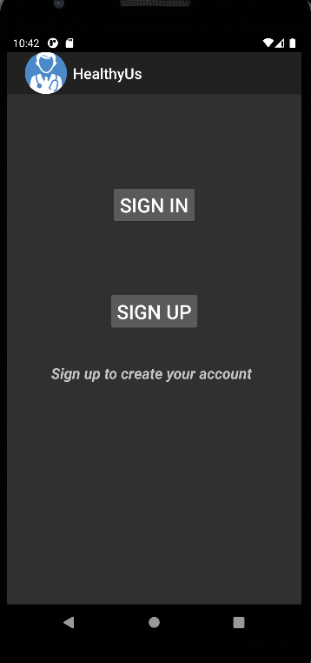
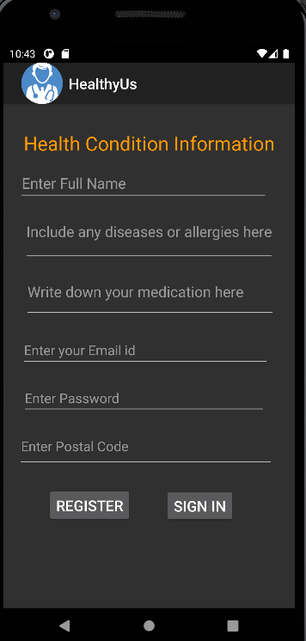

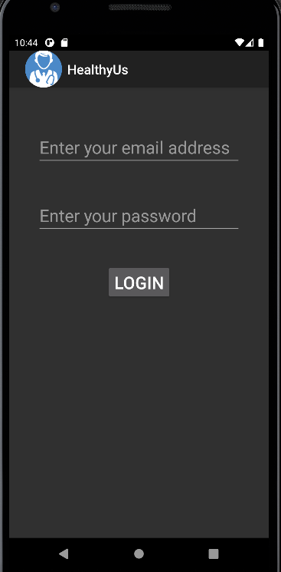
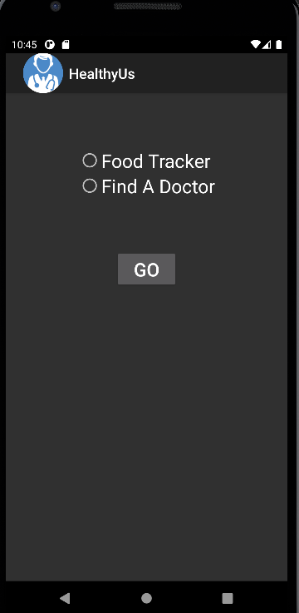

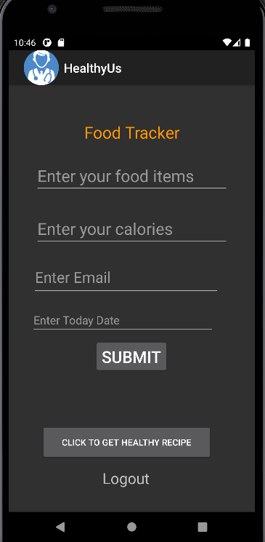
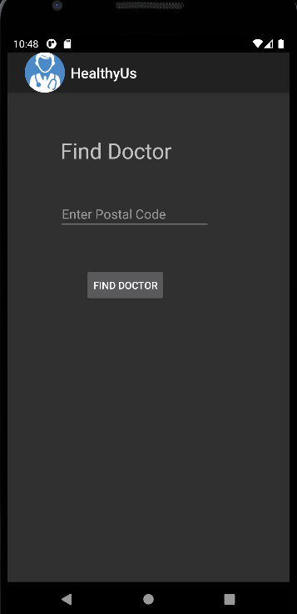

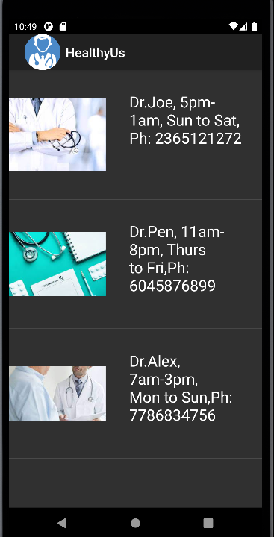
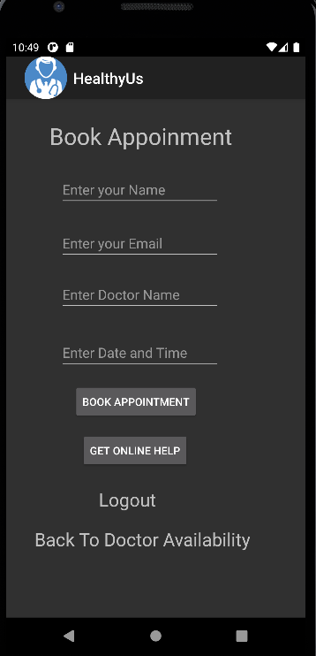
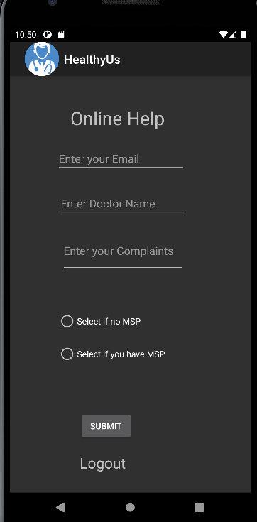
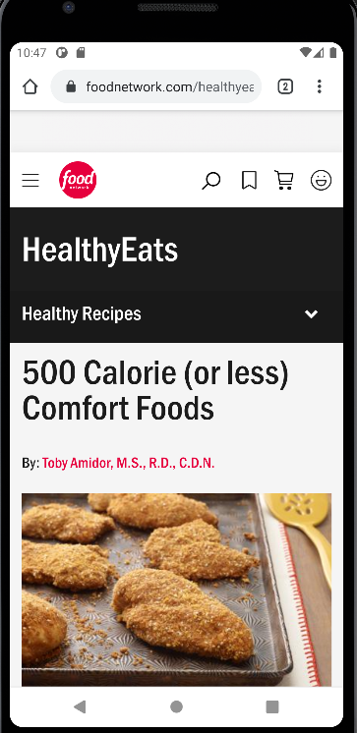

Database
The ER Diagram representing the tables and is attributes is shown below
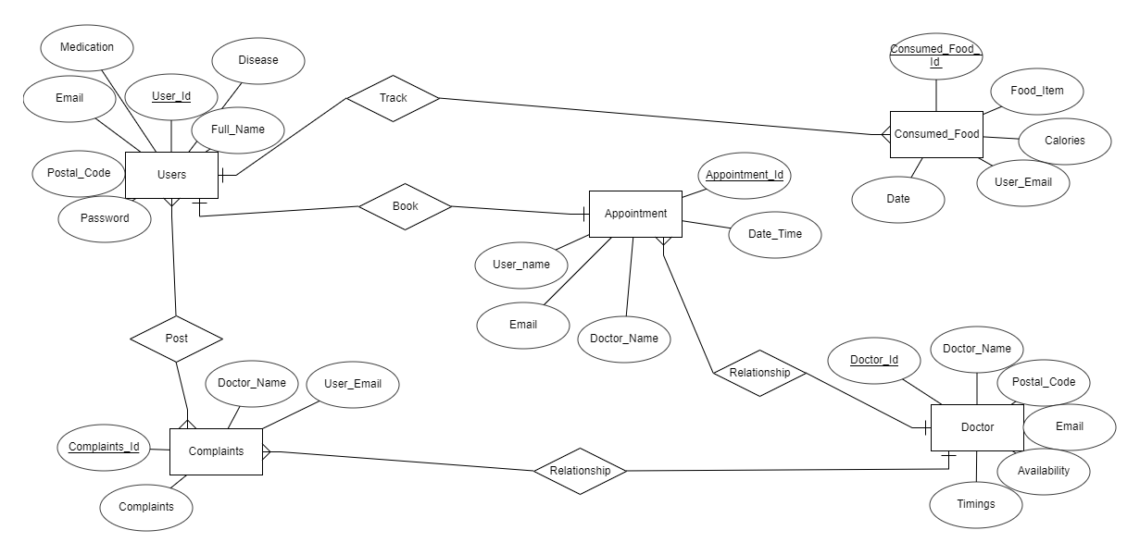

Summary
To summarize, we have created an application containing thirteen screens in total. The overview of features in each activity is explained in the App Activities and Classes section above. The database tables and their attributes are diagrammatically represented using an ER Diagram.

References
Food Network's Healthy Eats. (n.d.). Retrieved from Food Network: https://www.foodnetwork.com/healthyeats/recipes/2013/01/500-calorie-or-less-comfort-foods

